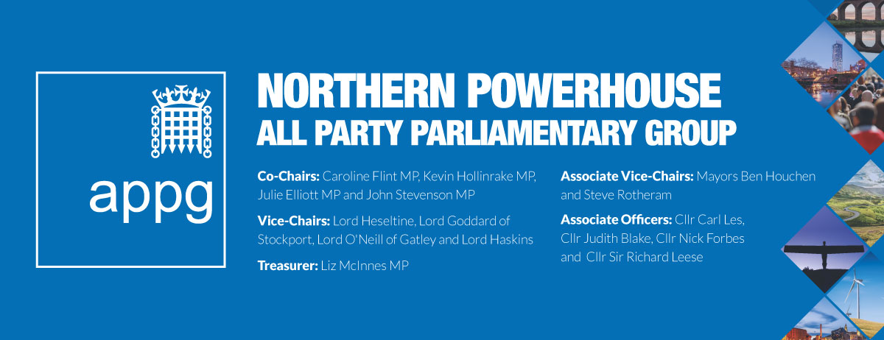
MINUTES
Investing in the North: Securing long-term finance for the Northern Powerhouse
Tuesday 5th June, 3pm – 4.30pm in Committee Room 9, House of Commons
Non-Verbatim Minutes

John Stevenson MP and Julie Elliott MP, Co-Chairs of the Northern Powerhouse APPG, welcomed all attendees to the meeting and thanked the Minister for his time.

Robert Jenrick MP, Exchequer Secretary at HM Treasury introduced himself as an embodiment of Manpool, having parents from Manchester and Liverpool respectively. He acknowledged that current problems with Northern Rail is an important investment issue which people were right to raise.

He committed his support to the Northern Powerhouse and other regions and re-iterated the need for the UK to become less London centric stating the Northern Powerhouse was “core to our strategy for country and the economy”. He shared the ambition of the Northern Powerhouse and is a strong advocate of it in the Treasury.

He referenced the original concept of the Northern Powerhouse and progress made so far listing the following:
- Transport – the establishment of Transport for the North and a total of £13 billion to be spent on transport in the North between 2016 and 2021.
- Cultural investment - £80 million given to the former Granada studios, Great Exhibition of the North, the saving of Wentworth and Channel 4 re-location potential.
- Science and technology – more money for R&D, and the Make Smarter pilot in the North West
- Increased economic potential - the British Business Bank’s Northern Powerhouse Investment Fund, a commitment to get behind Northern businesses such as Sirius Minerals.
- Greater Devolution – the North has had three Mayors for a year now and he welcomed Dan Jarvis’ election a Sheffield City Mayor. He re-stated that the Government and HMT are enthusiastic and want to see more deals done and are talking to a number of local councils and areas about the best way of taking forward devo proposals.
Keith Morgan, Director of the Northern Powerhouse Investment Fund (NPIF) and CEO of the British Business Bank, explained that the NPIF was set up with the 10 Northern LEPs and provides a £400million fund which is operational across whole North. £80 million has so far been invested in 250 businesses. To date the bank has given 70,000 loans.

He highlighted that there are as many high growth businesses in the North as there are in London: 20% in North, 20% in London. However, 50% of equity support is invested in London. Only some of this is due to distance and time for travel from London. The NPIF is therefore creating networks outside of London with a £100 million of Angel investment being put aside for investment in the regions. 20 people are now on the ground giving businesses knowledge about the fund and there is an online hub.

The money for NPIF was mostly from the European Investment Bank. How it will work in future with the Shared Prosperity Fund needs to be determined but the initiative is based on collaboration, which has been the key factor to its success so far, and should be continued to be funded.

Lord Heseltine, Vice-Chair, Northern Powerhouse APPG, began by saying that he felt that the devolution agenda had run out of steam due to Brexit and Whitehall reverting to type. He referred to the “botched” job in Sheffield and said that “we need a devolution deal for Yorkshire.” He also called for devolution of the economy. Funds should be combined in one pot for Local Authorities to bid. This is a proven model that worked with the last Chancellor.

Cllr Judith Blake, Leader, Leeds City Council, Associate Officer, Northern Powerhouse APPG, said that investment follows confidence and the sense of confidence in the North has really picked up in the last few years. The cities who are working together have really started to achieve things. But still the North’s potential is grossly underestimated. To fulfil it we need further fiscal devolution. Only 4p of every £1 raised in tax in the North is actually spent locally.

She stated that the transport system in the North has, for years, been a victim of systematic under-funding and said that, “our assets are our people and decisions regarding education need to be decentralised.” She emphasised that Yorkshire devolution is a serious proposition. It’s not just about brand and identity; it makes sound economic sense for the region given its many attributes including; in technology and advanced manufacturing. She said One Yorkshire devolution would recognise the power of Leeds and believed that there is a groundswell in favour. Judith welcomed the Minister’s comments and said she would like to take up his offer to continue discussions on Yorkshire.

Lord O’Neill of Gatley, Vice-Chair, Northern Powerhouse Partnership and Vice-Chair, Northern Powerhouse APPG, made a general observation: themed investment funds are not always the best way forward but where there is clear evidence of market failure then they are very necessary so what NPIF doing is welcomed.

He also said that if a concept is powerful and convincing investment will come. Property prices have already peaked in London but in other areas, especially the North West, they are still growing which is good. We need to get the PM and Chancellor to bang on about the Northern Powerhouse and private investment will follow.

Finally, he said that one thing he has learnt is never to let a crisis go to waste. The current Northern Rail debacle is an opportunity for Transport for the North (TfN) to become something serious. TFL has been crucial for London agglomeration, and TfN should be empowered to make a similar contribution.

Julie Elliott MP invited questions and contributions from the floor. Mike Amesbury MP asked for the new framework for devolution as Cheshire is “chomping at the bit” for a deal. Adam Simpson of Barclays said thematic funds do encourage applications, and they too have a Northern Powerhouse business fund and an apprenticeship deal. Martin Vickers MP remarked that he is a supporter of metro mayors but felt that those without one are being disadvantaged.

Robert Jenrick MP replied that there is a challenge when you look outside metropolitan areas. He said James Brokenshire and Jake Berry are in ongoing conversations but central Government never wanted to impose deals: they want them to have clear local support not be top-down. Lord O’Neill welcomed the Barclays investment initiative as a great thing and said he hoped competitors will follow. He commented that if the Government had Northern Powerhouse as one of its five top priorities then Barclays would be doubling the investment.

John Grogan MP said he was pleased to hear Minister indicate that HMT would meet regarding Yorkshire devolution. Jason McCartney said we need to look at towns, like Huddersfield, not just cities. Jamie Reed of Sellafield asked how you get growth alongside de-population. Lord O’Neill said that if an area is losing people then it needs a massive increase in productivity. He concluded by saying that a recent Cabinet Committee had met and there are definite noises that the Northern Powerhouse is back.

Urgent item: The Northern Rail franchise

Kevin Hollinrake MP and Caroline Flint MP, co-chairs of the Northern Powerhouse APPG invited Henri Murison Director, Northern Powerhouse Partnership, highlighted that today every significant regional paper in the North had carried headlines calling for action and had demonstrated their support for more powers to be given to TfN. There will be an inquiry into the Northern timetabling issues. Steps need to be taken learn from mistakes and to get this crisis solved. The Northern Mayors are also actively working to resolve these issues. Businesses are reporting that it is taking workers 2 hours to get to work – adversely affecting productivity. The current crisis cannot continue.

Kevin Hollinrake MP asked whether local authorities and Mayors want to give up powers to TfN? Henri Murison said the ‘ask’ is not for that model but to be given the discretionary powers of Network Rail. Councillor Judith Blake also assured the meeting there was no blockage from leaders and announced that she will be working with the Minister to undertake a review about the timetabling issue.

Mary Robinson MP said here has been ‘rail carnage’ across her constituency with 183 routes cancelled on one small station. Who knew what, when? For example, was anyone aware of the impending problems at the April meeting of TfN? Caroline Flint MP called for all conversations about this to be put in the public domain.

Thelma Walker MP said she had met the Secretary of State and everyone was very apologetic. Whilst they have said they will invest more that doesn’t address the here and now? Mike Amesbury MP said TFN needs teeth: “let’s make our own mistakes” not be victim of other’s. Cllr Judith Blake said the Secretary of State is ultimately responsible but difficult to get clarity on accountabilities: Northern Rail for example implemented the emergency timetable. Overall must turn this into a way to get powers.

Lord Heseltine said his approach is “show me the problem and show me the person in charge and then change them”. Maybe TfN needs to be re-constituted. Jonathan Spruce, of TfN, said they do not want to suck up powers but happy to draw them down from Government. All these problems could happen again. TfN do have 30 year plan but they are still dependent on Network Rail. Need the power to direct Network Rail.

Kevin Hollinrake MP closed the meeting by stating that there was a clear need to make sure urban and rural passengers get the rail service they deserve and MPs need to work together to make the case and ensure no one is left behind. This is not a case of poor Northerners begging for more but an opportunity to make the case and raise awareness that more and better transport would be good the growth and good of all the UK.

Meeting closed

Date of Next Meeting: tbc

Prepared by the Secretariat of the NPAPPG.

